Relativistic Polytropes

Matthew Hurley

March 7, 2014

Physics 331 Course Project

Goal: The goal of this project is to model the stellar interior of a White Dwarf Star using solutions to the Lane-Emden equation, otherwise known as polytropes.

White Dwarf Stars are extremely dense remnants of stars that are supported by electron degeneracy pressure. A white dwarf can form in one of two primary ways. The first way is mass loss in a binary system, which occurs when a star in a binary system has its mass stripped away by its neighboring star until only a degenerate core is left. This results in many of the helium white dwarfs that we see today. The second way is through the collapse of a star that is hot enough to fuse helium into carbon and oxygen. When the star collapses, it creates a planetary nebula with its degenerate core at the center, called a carbon-oxygen white dwarf. When the term degenerate is used, it is referring to a pressure that is reached in which the electrons in the molecules of the star can’t get any closer to each other without gaining energy. A star’s gravitational field pulls its layers in on itself, and is stable only when pressure pushing out on those layers balances the gravitational pull. In a main sequence star, this pressure is typically dependent on the temperature of the core of the star. For white dwarfs, however, the degeneracy pressure is a result of Pauli’s exclusion principle, which says that electrons can’t be in the same energy level. The more electrons added to a particular volume, the more that need to jump to a higher energy level, a requirement that creates a pressure. Electron degeneracy pressure is established when gravity from the mass of a star overcomes the pressure pushing it out, causing the star collapse until it reaches electron degeneracy pressure and, given that the star is not too massive, discontinues its collapse to become a stable white dwarf. If the white dwarf becomes too massive, or the original collapsing star was too massive, then electron degeneracy pressure gives in either to neutron degeneracy pressure (forming a neutron star) or to form a black hole. The maximum mass of a white dwarf is called the Chandrasekhar limit, which is 1.44 solar masses. When degeneracy pressure is reached fusion discontinues in the star. Interestingly, if a white dwarf gains mass, its radius actually decreases. This is because in a degenerate condition, pressure changes very little even if more mass is added. More mass creates a larger gravitational pull, and gravity shrinks the star and increases the density. All of this will be important to keep in mind when modeling white dwarfs with polytropes.

The degenerate state is what leads to the modeling of white dwarfs using a polytropic model. Polytropes are solutions to the Lane-Emden equation, which is a form of Poisson’s equation for gravitational potential of self-gravitating, spherically symmetric, polytropic fluids. Self-gravitating refers to the stars inward pull on itself. The Lane-Emden equation can be derived from the Poisson’s equation and has the form:

 \frac{1}{\xi^2} \frac{d}{d\xi} \left({\xi^2 \frac{d\theta}{d\xi}}\right) + \theta^n = 0 

Solutions to this give polytropes, which are equations of state that typically take the form:

 P = K \rho^{1 + \frac{1}{n}}\, 

where “n” is called the polytropic index. Because of a white dwarfs degenerate condition, the star’s thermal condition does not affect its pressure; such a condition is when a polytropic index can be used, and it is a good approximation if the star is assumed to be completely degenerate and in hydrostatic equilibrium. We use polytropes because we can model the star in relativistic terms which accounts for the Chandrasekhar limit. The non-relativistic, or Newtonian model does not account for the limit.

For our purposes, we will most likely be solving the Lane-Emden equation for n=1.5 (for non-relativistic polytropes) and n=3 (for relativistic polytropes). We will use both forms because a good way to estimate the pressure is in the form:



where p1 is the non-relativistic pressure and p2 is the relativistic pressure. The white dwarf is very complicated, but is typically relativistic in the interior and non-relativistic near the exterior, which is why we add the two together. The total pressure and density can then be approximated by:



We can then solve for the pressures in the previous relationship for radius as a function of mass, and plot the mass radius relationship. The ultimate goal of this project is to solve the Lane-Emden equation for the two specified indices n = 1.5 and n = 3 and then use those solutions to plot the mass radius relationship for white dwarf stars. What we are looking for is the radius to go to zero as the mass approaches the Chandrasekhar limit of 1.44 solar masses. We also want to show the relationship between a model including relativistic polytropes and one that only includes non-relativistic polytropes. Our plot will hopefully look similar to the following:

(Fermi gas is a way to refer to the degenerate electrons, since they are fermions)

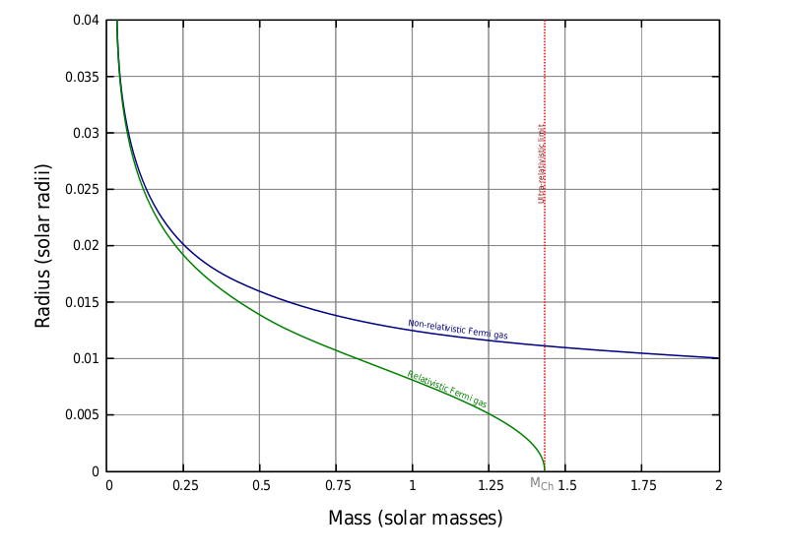

This next portion draws many of the techniques that will be used from *Stellar Interiors* by Hansen, Kawaler, and Trimble.[1]

The Lane-Emden equation will be treated as an initial value problem integrating from ξ = 0

to θn = 0. It must be broken into two first order equations. The new variables x = ξ, y = θn, z = (dθn/d ξ) = (dx/dy) will be used to rewrite the Lane-Emden equation as

dy/dx = z

dz/dx = -yn - 2z/x

Then the Runge-Kutta 4th order integrator will be used to carry out the integration for both differential equations. The book lays out a fixed integrator, but we may use an adaptive step integrator. The boundary at the origin causes dz/dx to be indeterminate, so the problem will probably need to be defined as having a boundary condition close to ξ = 0 but not at ξ = 0; i.e 0 < x<< 1. The outer surface of the polytrope is reached when θn = y crosses zero. It is beneficial to make the step size small near this point to determine exactly where it is, and possibly use interpolation.

Here are some parameters for n = 1.5, 2, and 3 polytropes.

|  |  |  |  |
| --- | --- | --- | --- |
| Index (n) | ξ1 | θ’(ξ1) | \langle\,\,\rangle ρc/ ρ |
| 1.5 | 3.6538 | -0.20330 | 5.991 |
| 2.0 | 4.3529 | -0.12725 | 11.402 |
| 3.0 | 6.8969 | -0.04243 | 54.183 |

1. Hansen, Carl, Steven Kawaler, and Virginia Trimble. *Stellar Interiors: Physical Principles, Structure, and Evolution*. New York: Springer-Verlag New York, 2004.